**Assignment-4**

ESP32 Programming with IBM

Cloud

**Question-1:**

Write code and connections in wokwi for ultrasonic sensor. Whenever distance is less than 100cms

send “alert” to ibm cloud and display in device recent events.

Upload document with wokwi share link and images of ibm cloud.

**Solution:**

#include <WiFi.h>//library for wifi #include

<PubSubClient.h>//library for MQtt

#define ECHO_GPIO 12

#define TRIGGER_GPIO13

#define MAX_DISTANCE_CM 100 // Maximum of 5 meters

#include "Ultrasonic.h"

Ultrasonic ultrasonic(13, 12); intdistance;

void callback(char* subscribetopic, byte* payload, unsigned intpayloadLength);

//-------credentialsof IBM Accounts------

#define ORG "bxddo9"//IBM ORGANITION ID

#define DEVICE_TYPE "ESP32"//Device type mentioned in ibm watson IOT Platform#define DEVICE_ID "Assign4"//Device ID mentioned in ibm watson IOT Platform #define TOKEN

"45625689713" //Token

String data3; float h, t;

//-------- Customise the above values -------- char server[] = ORG ".messaging.internetofthings.ibmcloud.com";// Server Name char publishTopic[] = "iot- 2/evt/Data/fmt/json";// topic name and type of event perform and format in which data tobe send

char subscribetopic[] = "iot-2/cmd/command/fmt/String";// cmd REPRESENT command type ANDCOMMAND IS TEST OF FORMAT STRING char authMethod[] = "use-token-auth";// authentication method char token[] = TOKEN; char clientId[] = "d:" ORG ":" DEVICE_TYPE ":" DEVICE_ID;//client id

//

WiFiClient wifiClient; // creating the instance for wificlient

PubSubClient client(server, 1883, callback ,wifiClient); //calling the predefined client id bypassing parameter like server id,portand wificredential

void setup()// configureing theESP32

{

**Serial**.begin(115200); delay(10);

**Serial**.println();

wificonnect();

mqttconnect();

} void loop()// RecursiveFunction

{ distance =

ultrasonic.read(CM);

if(distance < 100){

**Serial**.print("Distance in CM: ");

**Serial**.println(distance);

PublishData(distance);

delay(1000); if

(!client.loop()) { mqttconnect();

}

}

delay(1000);

}

/*.....................................retrieving toCloud. ............................................................................................................................... */ void PublishData(float temp) { mqttconnect();//function call for

connecting to ibm

/* creating the String in in form JSon to update the data to ibmcloud */

String payload = "{\"Alert Distance:\":";payload +=

temp; payload += "}";

**Serial**.print("Sending payload: ");

**Serial**.println(payload);

if (client.publish(publishTopic,(char*) payload.c_str())) {

**Serial**.println("Publish ok");// if it sucessfully upload data on the cloud then it willprint publish ok in Serial monitor or else it will print publish failed

} else {

**Serial**.println("Publish failed");

}

} void mqttconnect() { if

(!client.connected()) {

**Serial**.print("Reconnecting client to ");

**Serial**.println(server);

while (!!!client.connect(clientId, authMethod,token)) {

**Serial**.print("."); delay(500);

}

initManagedDevice();

**Serial**.println();

} } void wificonnect() //function defination forwificonnect {

**Serial**.println(); **Serial**.print("Connecting

to ");

WiFi.begin("Wokwi-GUEST", "", 6);//passing the wifi credentials to establish the connectionwhile (WiFi.status() != WL_CONNECTED) { delay(500);

**Serial**.print(".");

}

**Serial**.println(""); **Serial**.println("WiFi

connected");**Serial**.println("IP address: ");

**Serial**.println(WiFi.localIP());

} void initManagedDevice() {

if (client.subscribe(subscribetopic)){

**Serial**.println((subscribetopic));

**Serial**.println("subscribe to cmd OK");

} else {

**Serial**.println("subscribe to cmd FAILED");

}

} void callback(char* subscribetopic, byte* payload, unsigned intpayloadLength) {

**Serial**.print("callback invoked for topic: ");

**Serial**.println(subscribetopic); for (int i = 0; i <

payloadLength; i++) {

//Serial.print((char)payload[i]); data3 +=

(char)payload[i];

}

**Serial**.println("data: "+ data3);

if(data3=="lighton") {

**Serial**.println(data3);

}

else

{

**Serial**.println(data3);

} data3="";

}

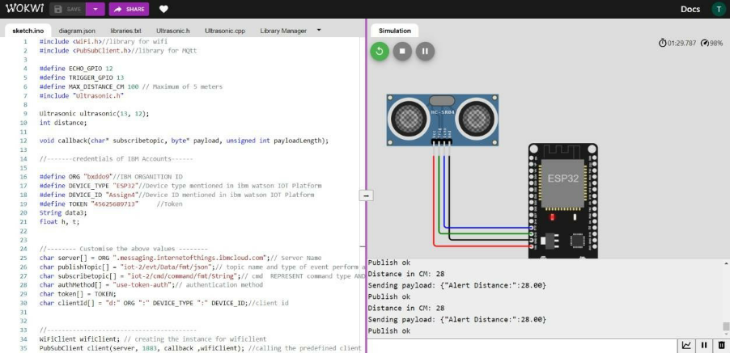

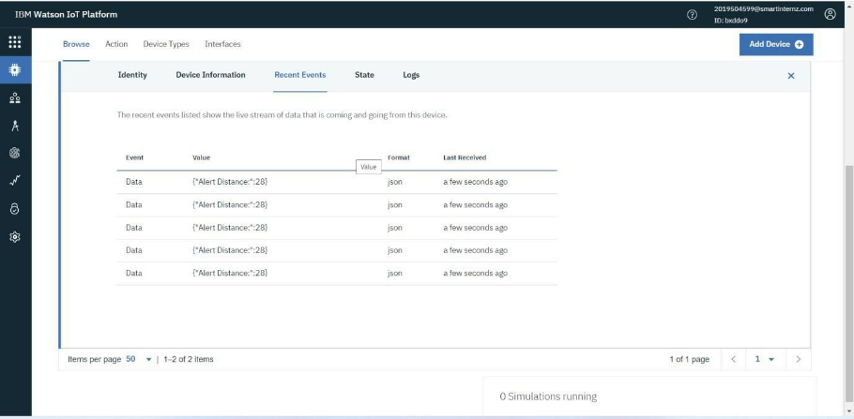

**Wokwi share link: https://wokwi.com/projects/346690179890676307**